Product manual

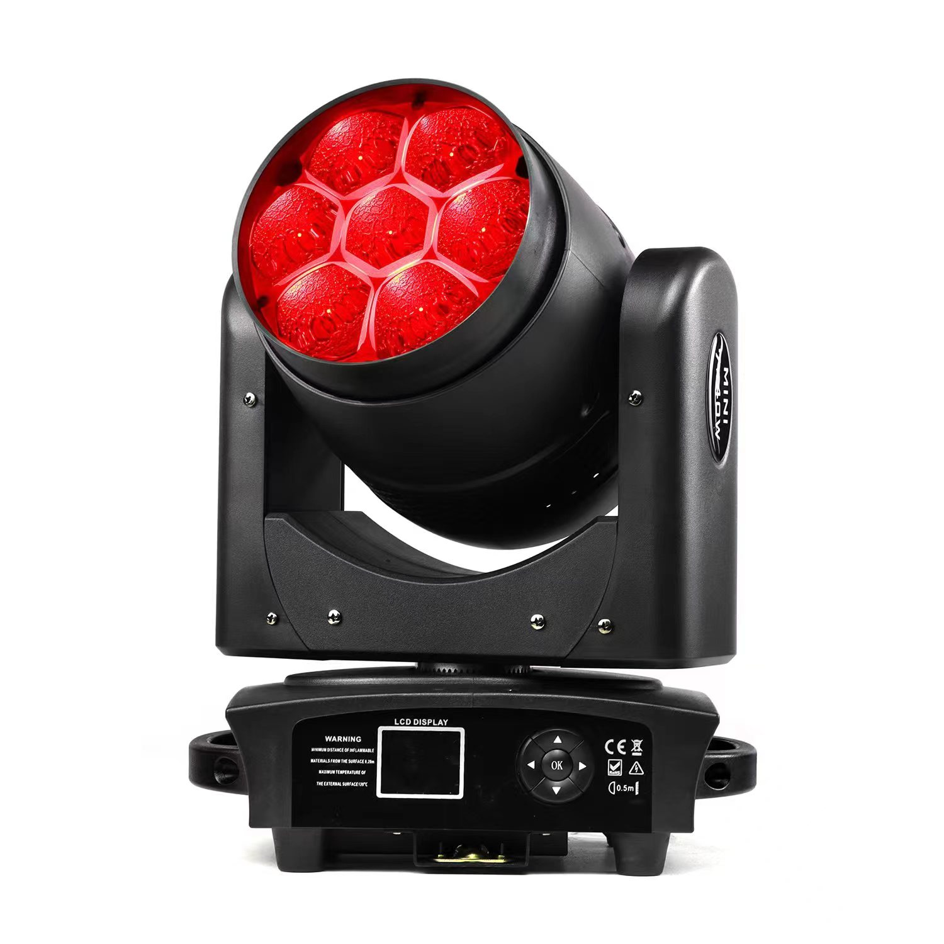

MINIB740

1 SECURITY TIPS
WARNING!!! To reduce the risk of fire, electric shock, or injury to persons, follow these important safety instructions:
- non-professionals, not to disassemble the light arbitrarily and lighting accessories inside.
- rated voltage range: AC110V-120V/60Hz or AC200V-240V / 50HZ (to be selected).
- not beam irradiate the flammable materials, flammable materials and the lamp should be maintained at least 1M over the distance.
- lamps used in ambient temperature: -15 ℃ -40 ℃, the highest temperature of the surface of the lamp: 60 ℃.
- to keep away from the liquid substance and humid environment.
- before using the lights must ensure the good grounding, can not install charging and remove any parts.
- the installation of lamps, must be fixed screw fasteners with additional security cable and regular inspection.
- lamps consecutive working hours is not recommended more than 10 hours.
- should stop using the lights in time when happens unusual conditions during the process
- lamp parts of the rotation, external accessories and paste parts should be regular inspected, such as the emergence of loose and rock, should be reinforced in a timely manner to prevent the accident.
- lamps adopt strong winds to refrigerate, it is easy to accumulate the dust, so you have to clean it weekly especially the cooling air opening, otherwise the dust will plug leading to poor light

2 TECHNOLOGY REFERENCE
Input voltage: AC100-240V, 50/60HZ
Power Consumption: 350W
Light Source:7*40W RGBW 4 in1 Osram LED
Average life: 50,000 hrs
Color temperature: 2500-8000k
Functional system: a single LED controllable point
Dimming: 0-100% linear electronic dimming
Strobe: 1-25 hz, linear modulation
Control mode: DMX512
DMX Channel:BAS17CH / BAS21CH / EXT21CH / EXT29CH
Seamless splicing mirror plate design, aspheric lens structure
Light body material: die-cast aluminum structure LED LCD screen
Horizontal scanning: 540 electronic error correction
Vertical scanning: 270 electronic error correction
Ambient temperature: 0°C-45°C
Cooling system: forced air cooling
Protection level: IP20
Dimensions: 11.8”x8.7”x16.5”in
Weight: 10KG
3 Board Instruction
Main Menu | Second | Third | Fourth
Dmx Address | 000 - 512
Fixture | Dmx Mode | BAS17CH / BAS21CH / EXT21CH / EXT29CH
Fixture | Run Mode | DMX / Host / Sound
Fixture | Pan Invert | Close / Open
Fixture | Tilt Invert | Close / Open
Fixture | No Dmx Signal | Clear / Hold
Fixture | Sound Control | 0 -- 99
Manual | Pan | 000 - 255
Manual | Pan Fine | 000 - 255
Manual | Tilt | 000 - 255
Manual | Tilt Fine | 000 - 255
Manual | ⁞ | ⁞
Info | Temperature | Head Temp | xxxC
Info | Software Version | Panel | Vx.xx
Info | Software Version | Network | Vx.xx
Factory | Password | 000 - 255
Factory | Pan | 000 - 255
Factory | Tilt | 000 - 255
Factory | Zoom | 000 - 255
Factory | Red | 000 - 255
Factory | Green | 000 - 255
Factory | Blue | 000 - 255
Factory | White | 000 - 255
Fixture Reset | Motor Reset | Cance / Run
Fixture Reset | Factory | Cance / Run
Display | Language | CH / EN
Display | Display Flip | Normal / Reverse
Display | Display Mode | 60s / Show
Network | Protocol | ArtNet / sACN
Network | KlingNet | Disable / Enable
Network | Universe | 000 - 255
Network | Ip Address | xxx.xxx.xxx.xxx
Network | Subnet Mask | xxx.xxx.xxx.xxx

4 DMX CHANNEL SHEET
Basic RGBW
DMXParameternumber | Function | DMX值 | 详细信息
1 | Red | 0-255 | RED linear 0 - 100%
2 | Green | 0-255 | GREEN linear 0 -100%
3 | Blue | 0-255 | BLUE linear 0 -100%
4 | White | 0-255 | WHITE linear 0 -100%
5 | CTO | 0-255 | CTO
6 | Macro color | 0-255 | MACRO COLOR
7 | Strobe | 0 - 3 | Light OFF
7 | Strobe | 4 - 103 | Strobe effect linearly variable frequency from low (1Hz) to fast (25Hz)
7 | Strobe | 104 - 107 | Light ON
7 | Strobe | 108 - 207 | Pulsation at linearly variable speed from slow (0.5 Hz) to fast (25 Hz)
7 | Strobe | 208 - 212 | Light ON
7 | Strobe | 213 - 225 | Random Slow Strobe effect
7 | Strobe | 226 - 238 | Random Medium Strobe effect
7 | Strobe | 239 - 251 | Random Fast Strobe effect
7 | Strobe | 252 - 255 | Light ON
8 | Dimmer | 0-255 | DIMMER
9 | Dimmer fine | 0-255 | DIMMER FINE (16 bit)
10 | Pan | 0-255 | PAN
11 | Pan fine | 0-255 | PAN FINE
12 | Tilt | 0-255 | TILT
13 | Tilt fine | 0-255 | TILT FINE
14 | Zoom | 0-255 | ZOOM
15 | Color crossfade | 0-255 | COLOR CROSSFADE
16 | Function | 0-255 | Retain
17 | Reset | 0-25 | Unused range
17 | Reset | 26-255 | Wait 5 seconds for automatic restart
Basic RGBW 16bit
通道值 | Function | DMX值 | 详细信息
1 | Red | 0-255 | RED linear 0 - 100%
2 | Red fine | 0-255 | RED FINE (16 Bit)
3 | Green | 0-255 | GREEN linear 0 -100%
4 | Green fine | 0-255 | GREEN FINE (16 Bit)
5 | Blue | 0-255 | BLUE linear 0 -100%
6 | Blue fine | 0-255 | BLUE FINE (16 bit)
7 | White | 0-255 | WHITE linear 0 -100%
8 | White fine | 0-255 | WHITE FINE (16 bit)
9 | CTO | 0-255 | CTO
10 | Macro color | 0-255 | MACRO COLOR
11 | Strobe | 0 - 3 | Light OFF
11 | Strobe | 4 - 103 | Strobe effect linearly variable frequency from low (1Hz) to fast (25Hz)
11 | Strobe | 104 - 107 | Light ON
11 | Strobe | 108 - 207 | Pulsation at linearly variable speed from slow (0.5 Hz) to fast (25 Hz)
11 | Strobe | 208 - 212 | Light ON
11 | Strobe | 213 - 225 | Random Slow Strobe effect
11 | Strobe | 226 - 238 | Random Medium Strobe effect
11 | Strobe | 239 - 251 | Random Fast Strobe effect
11 | Strobe | 252 - 255 | Light ON
12 | Dimmer | 0-255 | DIMMER
13 | Dimmer fine | 0-255 | DIMMER FINE (16 bit)
14 | Pan | 0-255 | PAN
15 | Pan fine | 0-255 | PAN FINE
16 | Tilt | 0-255 | TILT
17 | Tilt fine | 0-255 | TILT FINE
18 | Zoom | 0-255 | ZOOM
19 | Color crossfade | 0-255 | COLOR CROSSFADE
20 | Function | 0-255 | Retain
21 | Reset | 0-25 | Unused range
21 | Reset | 26-255 | Wait 5 seconds for automatic restart
Basic RGBW 16bit
通道值 | Function | DMX值 | 详细信息
1 | Red Circle | 0-255 | RED CIRCLE linear 0 - 100%
2 | Green Circle | 0-255 | GREEN CIRCLE linear 0 - 100%
3 | Blue Circle | 0-255 | BLUE CIRCLE linear 0 - 100%
4 | White Circle | 0-255 | WHITE CIRCLE linear 0 - 100%
5 | Red Centre | 0-255 | RED CENTRE linear 0 - 100%
6 | Green Centre | 0-255 | GREEN CENTRE linear 0 - 100%
7 | Blue Centre | 0-255 | BLUE CENTRE linear 0 - 100%
8 | White Centre | 0-255 | WHITE CENTRE linear 0 - 100%
9 | CTO | 0-255 | CTO
10 | Macro color | 0-255 | MACRO COLOR
11 | Strobe | 0 - 3 | Light OFF
11 | Strobe | 4 - 103 | Strobe effect linearly variable frequency from low (1Hz) to fast (25Hz)
11 | Strobe | 104 - 107 | Light ON
11 | Strobe | 108 - 207 | Pulsation at linearly variable speed from slow (0.5 Hz) to fast (25 Hz)
11 | Strobe | 208 - 212 | Light ON
11 | Strobe | 213 - 225 | Random Slow Strobe effect
11 | Strobe | 226 - 238 | Random Medium Strobe effect
11 | Strobe | 239 - 251 | Random Fast Strobe effect
11 | Strobe | 252 - 255 | Light ON
12 | Dimmer | 0-255 | DIMMER
13 | Dimmer fine | 0-255 | DIMMER FINE (16 bit)
14 | Pan | 0-255 | PAN
15 | Pan fine | 0-255 | PAN FINE
16 | Tilt | 0-255 | TILT
17 | Tilt fine | 0-255 | TILT FINE
18 | Zoom | 0-255 | ZOOM
19 | Color crossfade | 0-255 | COLOR CROSSFADE
20 | Function | 0-255 | Retain
21 | Reset | 0-25 | Unused range
21 | Reset | 26-255 | Wait 5 seconds for automatic restart
Extended RGBW 16bit
通道值 | Function | DMX值 | 详细信息
1 | Red Circle | 0-255 | RED CIRCLE linear 0 - 100%
2 | Red Circle fine | 0-255 | RED CIRCLE FINE (16 bit)
3 | Green Circle | 0-255 | GREEN CIRCLE linear 0 - 100%
4 | Green Circle fine | 0-255 | GREEN CIRCLE FINE (16 bit)
5 | Blue Circle | 0-255 | BLUE CIRCLE linear 0 - 100%
6 | Blue Circle fine | 0-255 | BLUE CIRCLE FINE (16 bit)
7 | White Circle | 0-255 | WHITE CIRCLE linear 0 - 100%
8 | White Circle fine | 0-255 | WHITE CIRCLE FINE (16 bit)
9 | Red Centre | 0-255 | RED CENTRE linear 0 - 100%
10 | Red Centre fine | 0-255 | RED CENTRE FINE (16 bit)
11 | Green Centre | 0-255 | GREEN CENTRE linear 0 - 100%
12 | Green Centre fine | 0-255 | GREEN CENTRE FINE (16 bit)
13 | Blue Centre | 0-255 | BLUE CENTRE linear 0 - 100%
14 | Blue Centre fine | 0-255 | BLUE CENTRE FINE (16 bit)
15 | White Centre | 0-255 | WHITE CENTRE linear 0 - 100%
16 | White Centre fine | 0-255 | WHITE CENTRE FINE (16 bit)
17 | CTO | 0-255 | CTO
18 | Macro color | 0-255 | MACRO COLOR
19 | Strobe | 0 - 3 | Light OFF
19 | Strobe | 4 - 103 | Strobe effect linearly variable frequency from low (1Hz) to fast (25Hz)
19 | Strobe | 104 - 107 | Light ON
19 | Strobe | 108 - 207 | Pulsation at linearly variable speed from slow (0.5 Hz) to fast (25 Hz)
19 | Strobe | 208 - 212 | Light ON
19 | Strobe | 213 - 225 | Random Slow Strobe effect
19 | Strobe | 226 - 238 | Random Medium Strobe effect
19 | Strobe | 239 - 251 | Random Fast Strobe effect
19 | Strobe | 252 - 255 | Light ON
20 | Dimmer | 0-255 | DIMMER
21 | Dimmer fine | 0-255 | DIMMER FINE (16 bit)
22 | Pan | 0-255 | PAN
23 | Pan fine | 0-255 | PAN FINE
24 | Tilt | 0-255 | TILT
25 | Tilt fine | 0-255 | TILT FINE
26 | Zoom | 0-255 | ZOOM
27 | Color crossfade | 0-255 | COLOR CROSSFADE
28 | Function | 0-255 | Retain
29 | Reset | 0-25 | Unused range
29 | Reset | 26-255 | Wait 5 seconds for automatic restart

5 FIXED EQUIPMENT
Please keep the equipment far away from the flammable objects like finishing material, etc. keep at least 0.5m distance from the flammable objects.
Warning: using two lamp clamps fix the equipment on the bottom of the lamp holder according to the instruction. to make sure the place of install the lamp is safe and suitable ,and the installation point that have chosen is safety and reliable.
The place of installing the lamp must support the 10 times weight of the lamp itself. And test the pensile place and make sure the place isn’t out of the shape.
Must install the second protection when fixing the equipment like proper protective screening. The second protection is used to prevent drop off and lost of lamp and components.
Lamps can directly install the lamp holder , which is shown in the figure: 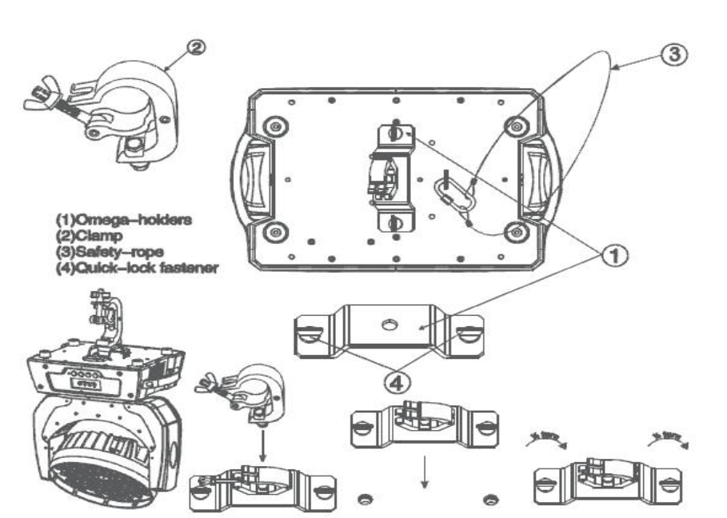

6 MAIN MACHINE CONNECTION
Please checking the power equipment supported.
Please put the plug of power source wire connect with the main power source .
( EU )Wire | Wire(America) | Direction of wire | General marks
Brown  Light blue  Yellow/Green | Black  White  Green | Live  Neutral  Earth | L  N  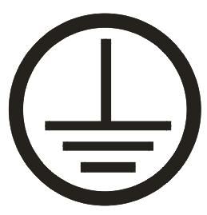

Warranty Card
Name Model Production Purchase

End User

Company Name:

Add:

Sale Store

Link man:
Tel: Stamp

Description: These must be truthfully fill, seal by the end-user and point-of-sale, or else the warranty will not work (warranty period and terms, see the following)
warranty period：one year since purchase warranty terms：1、If fail when using the product in normal state, you can made under the provisions of the warranty, show the warranty card and purchase bills(copy), and enjoy free maintenance service in a specific service center or the manufacturer.
2. The following will be the implementation of paid service:
(1)Without the effective warranty card
(2)There’s blank, alter and no point-of-sale name
(3)Fail caused by unresistance
(4)Fail caused by transportation or unloading
(5)Fail caused by not operate by manual
(6)Fail caused by disassemble without unauthorized
(7)Fail caused by using the unauthorized control system

Note:
Based on our company continue to improve the product, the statement containing data may have changed, and will not notice the change any more. Company retains its right to change specifications related when product is improved. Thanks for your understanding.

