LED 36 beam dyeing light manual

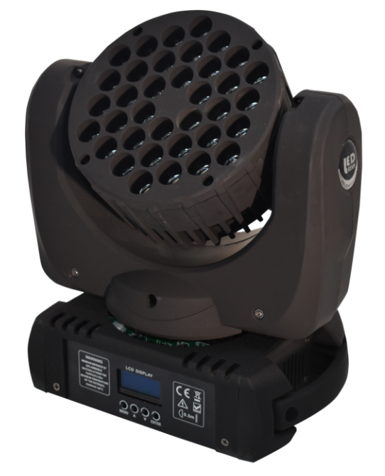

Voltage: AC90-240V 50/60HZ
Total power supply; 180W
Channel: 9 and 16 channels optional
Light source; Jingxin lamp beads 36 X3W, 8 red; 10 green; 10 blue; 8 white;
X axis; 540 degrees,
Y axis 270 degrees

DMX SET
001-512
Channel SET
9
512 DMX SET

9 channel

16
16cahnnel

Show Mode
Dmx Mode
DMX CONSOLE
Fast Mode

Fast Model

Slow Mode

Slow Model
Soud Mode

Soud Mode

Sound Sense
10-100

Sound Sense

Pan Inverse
OFF
X Motor forward

ON
X Motor reversal

Tite Inverse
OFF
Y Motor forward

ON
Y Motor reversal

While balance
R 0-255
RED
G 0-255

Green
B 0-255
e

BLUE
W 0-255

WHITE
Default
confinrm
YES
Initialize
the factroy
Fixture
REST
YES

REST
16 channel
channel | Features | Description
1 | Pan | 0-255 Adjust upward, turn forward, and reverse downward
2 | Tilt | 0-255 Adjust upward, turn forward, and reverse downward
3 | Total dimming | 0-255 Overall brightness adjustment
4 | R dimming | 0-255 Red brightness adjustment
5 | G dimming | 0-255 Green brightness adjustment
6 | B dimming | 0-255 Blue brightness adjustment
7 | W dimming | 0-255 White brightness adjustment
8 | Strobe | 0-255 Strobe adjustment, from slow to fast
9 | Motor running speed | 0-255 Pan&Tilt SPeed
10 | 0-10 | Other channels work
10 | 64-127 | Color combination change
10 | 128-191 | Color jump
10 | 192-255 | Color gradient
11 | Color auto | Dyeing from slow to fast
12 | Built-in effect | Built-in effect
13 | Built-in effect speed | Built-in effect speed
14 | Pan Fine | 0-255 Adjust upward, turn forward, and reverse downward
15 | Tilt Fine | 0-255 Adjust upward, turn forward, and reverse downward
16 | REST | 250-255 no affect; 250-255 REST
9 channel
channel | Features | Description
1 | Pan | 0-255 Adjust upward, turn forward, and reverse downward
2 | Tilt | 0-255 Adjust upward, turn forward, and reverse downward
3 | Total dimming | 0-255 Overall brightness adjustment
4 | R dimming | 0-255 Red brightness adjustment
5 | G dimming | 0-255 Green brightness adjustment
6 | B dimming | 0-255 Blue brightness adjustment
7 | W dimming | 0-255 White brightness adjustment
8 | Strobe | 0-10 no strobe; 11-255 Strobe adjustment, from slow to fast
9 | Motor running speed | 0-255 Pan&Tilt SPeed from slow to fast
555222222

